PHASE IV: PROJECT DESIGN
Date | 06 November 2025
Team ID | NM2025TMID08097
Project Name | To supply Leftover Food to Poor
Maximum Marks | 4 Marks

Title: Project Design Phase for “FoodConnect – To Supply Leftover Food To Poor”

1. Objective
The objective of the Design Phase is to create the visual, technical, and logical architecture of the FoodConnect application.
This phase translates the requirements defined earlier into a detailed design, ensuring that the system’s structure, interface, and automation flow align with project objectives — minimizing food waste and optimizing delivery logistics.
This design focuses on:
- Interface Design (UI/UX)
- Automation Design (Flows and Triggers)
- Security Model Integration
- Dashboard & Report Visualization

2. Design Overview
The design stage uses Salesforce’s declarative and programmatic features to model a robust, user-friendly system.
The FoodConnect app design is structured around:
- Five Core Custom Objects (Venue, Drop-Off Point, Volunteer, Task, Execution Details)
- Automated Flows for data entry and record creation
- Apex Triggers for pre-save validations and formula execution
- Dashboards for live data visualization
- Profiles & Sharing Rules for access management

3. User Interface (UI) Design

3.1 Lightning App Design
A custom Lightning App named “FoodConnect” was created to give NGOs and volunteers a seamless experience.
Steps:
- Navigate to Setup → App Manager → New Lightning App.
- Add App Name, Description, and choose the app logo.
- Configure navigation with the following tabs:
  - Home
  - Venues
  - Drop-Off Points
  - Tasks
  - Execution Details
  - Volunteers
  - Reports & Dashboards
Design Principle Used:
- Minimalist UI: Clean interface, large form spacing for clarity.
- Role-based Navigation: Admins access all tabs, volunteers see task-related ones only.

3.2 Home Page Design
The Home Page serves as the operational dashboard and record entry point.
Components Added:
- Screen Flow: "Venue Form Flow" for fast record creation.
- Embedded Dashboard: Shows total deliveries, distances, and volunteer activity.
- Informational Card: Displays a motivational banner image on food donation impact.

4. Automation Design
Automation ensures a hands-free workflow by minimizing manual interventions and maintaining data accuracy.

4.1 Screen Flow: Venue Form Flow
The “Venue Form Flow” simplifies data entry for NGO admins.
Flow Steps:
- Add Screen Elements → Venue Name, Email, Phone, Latitude, Longitude.
- Use Create Record Element → Store data in the Venue Object.
- Add confirmation screen → “Venue Record Created Successfully.”
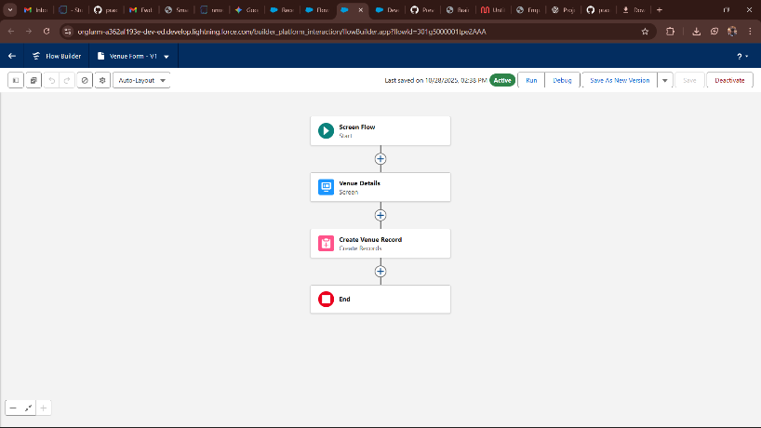

4.2 Apex Trigger Design
A custom Apex Trigger was designed on the Drop-Off Point object to auto-calculate the Distance Field using the formula:
DISTANCE(Drop_Off_Point_Location__c, Venue__r.Geolocation__c, 'km')
Trigger Steps:
- Event: Before Insert
- Function: Fetch associated Venue record.
- Calculate distance dynamically.
- Store result in “Distance__c” field.
Rationale:
This ensures every new Drop-Off Point record includes an accurate distance value before saving, enabling precise task assignment.

5. Security Design
The Security Model in Salesforce ensures data privacy and controlled access among users.

5.1 Profile-Based Access
- Volunteer Profile: Read and Create permissions on Volunteer and Task objects.
- NGO Admin Profile: Full CRUD access to all objects.
- System Admin: Access to all configurations.

5.2 Criteria-Based Sharing Rules
Two automated rules were defined:
- If Distance < 15 km → Share with Isha Volunteers Group.
- If Distance > 30 km → Share with NGO Coordinators Group.
Benefit:
This allows automatic filtering of records by geographic location, keeping data relevant and clutter-free.

6. Reporting and Dashboard Design

6.1 Reports
Custom report types were created to link:
- Venue → Drop-Off Point → Task
- Volunteer → Task → Execution Details

6.2 Dashboard Components
The dashboard visualizes real-time project impact using:
- Bar Chart: Total deliveries by volunteers.
- Pie Chart: Food category distribution (Veg / Non-Veg).
- Line Chart: Monthly volunteer participation trends.
- Table View: Task completion details.
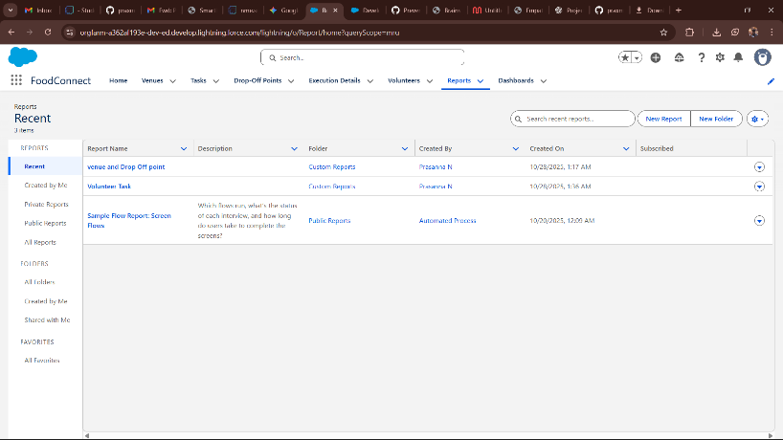

7. System Architecture Design
The system architecture integrates UI, automation, database, and reporting modules into one functional ecosystem.
Layer | Component | Function
Presentation Layer | Lightning App UI | User interaction interface
Logic Layer | Apex Triggers, Flows | Automates business logic
Data Layer | Custom Objects, Fields | Manages records and relationships
Analytics Layer | Dashboards, Reports | Provides insights and metrics

8. Design Constraints
Constraint | Impact | Solution
Formula field performance under large datasets | Slower computation | Use indexed fields for faster lookup
User error in Flow inputs | Invalid data records | Add validation rules
Dashboard refresh limits | Slight delay in real-time updates | Schedule refresh every 15 mins

9. Future Design Considerations
- Integration with Google Maps API for advanced geolocation tracking.
- Development of Mobile App Interface using Salesforce Mobile SDK.
- AI-based Food Demand Prediction System for NGOs.
These enhancements will further expand FoodConnect’s scalability and intelligence.

10. Summary
The Project Design Phase transformed theoretical requirements into a visual and technical framework.
Through the use of Salesforce Lightning, Flow Builder, Apex, and Dashboards, FoodConnect achieves an ideal balance between automation, user experience, and performance.
Key Achievements:
- Modern, intuitive Lightning App interface
- Fully automated data flow through Flows and Triggers
- Secure and role-based data accessibility
- Real-time reporting with visual dashboards

